CDN: content delivery network; used for caching and makes thing readily available.

Edge location: 70+, closest location, to perform searches. ( amazon data center)

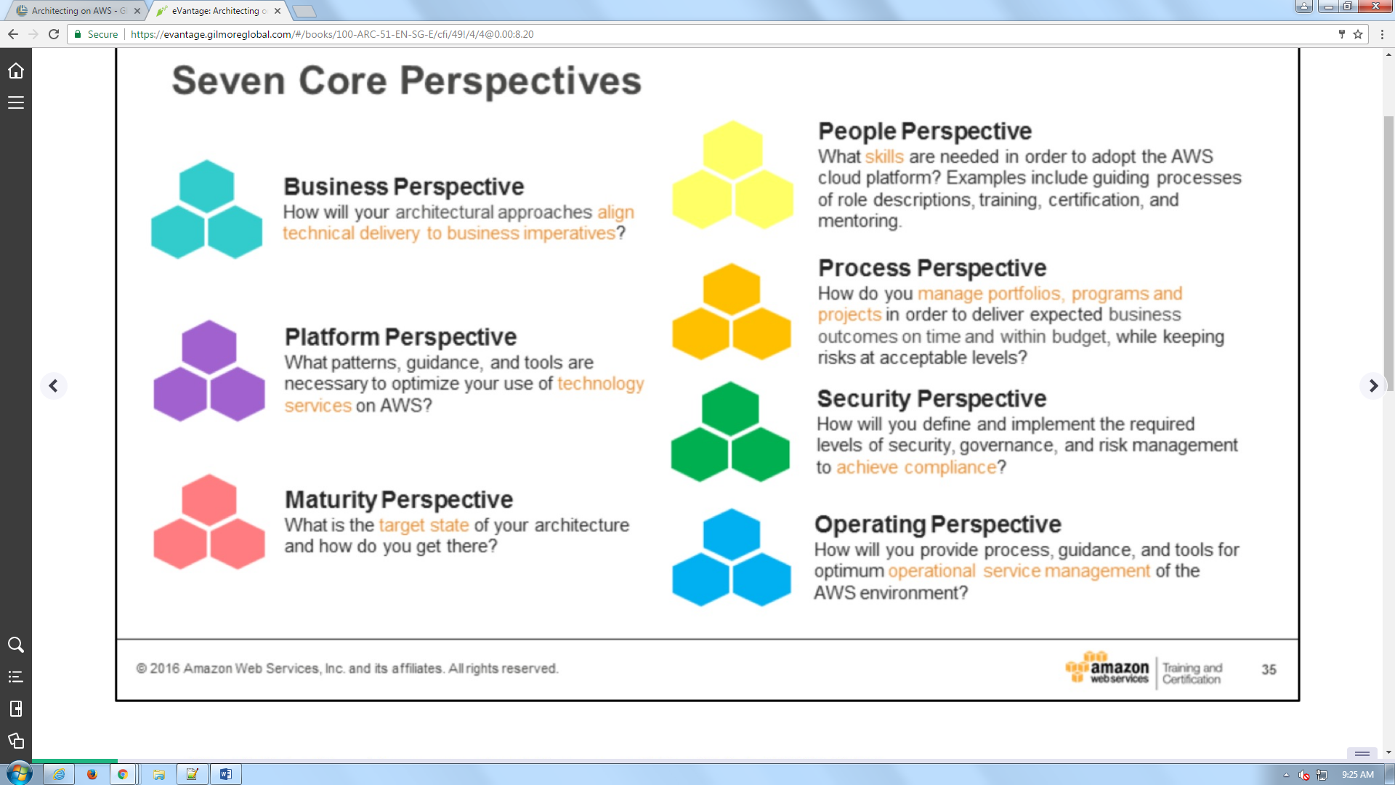

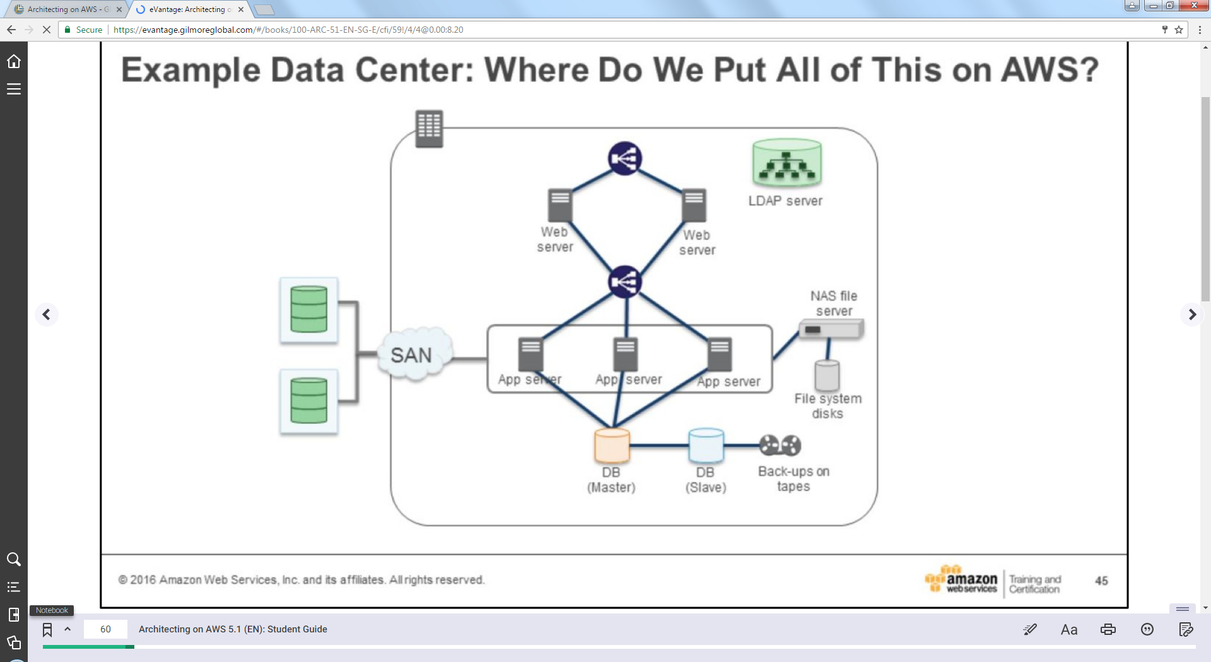

LDAP SERVER: Load balancer

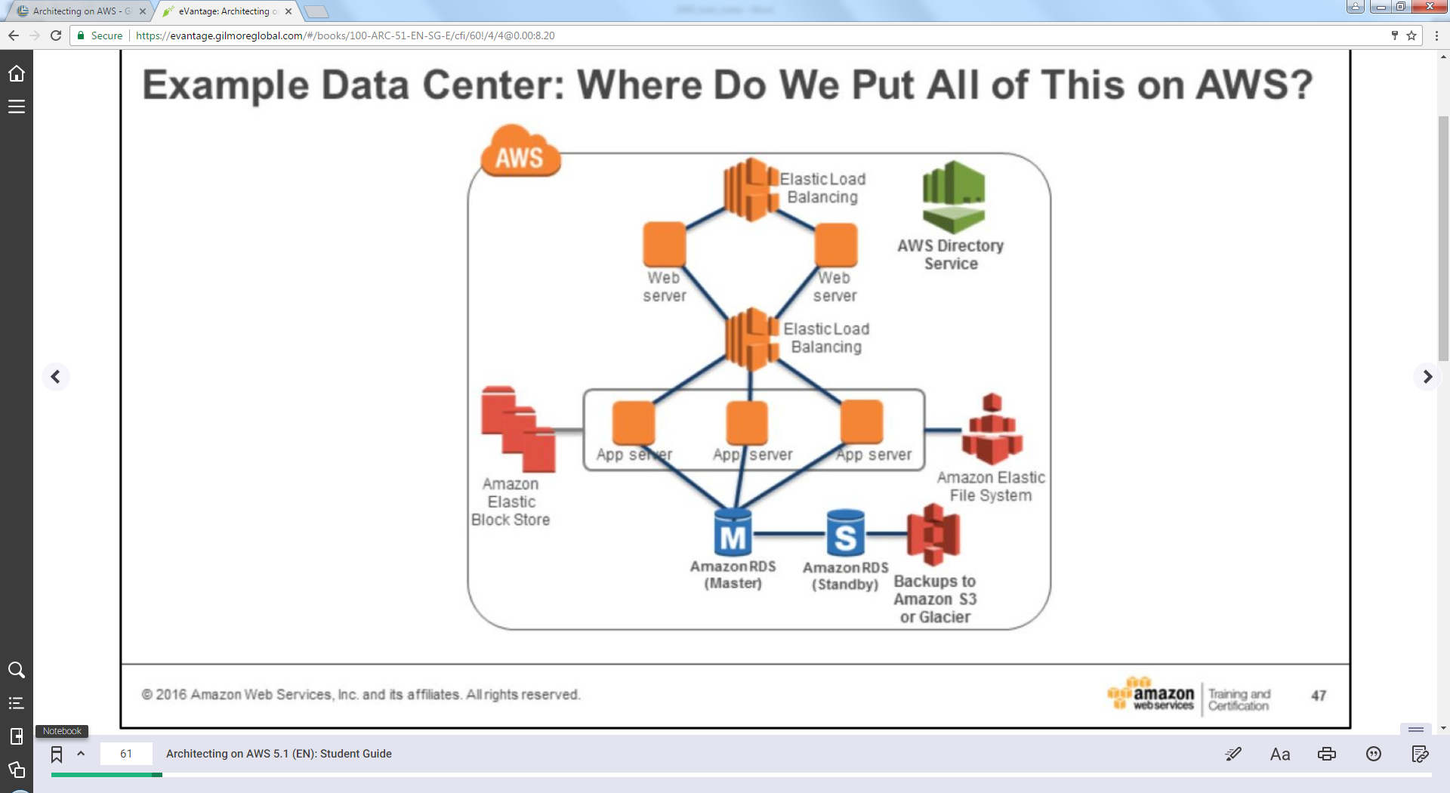

Amazon elastic file system: Shared storage

Loose coupling:

Make infrastructure more fluid and agile.

Eg:- load balancers

Lambda: server less architecture, it’s simple and manageable

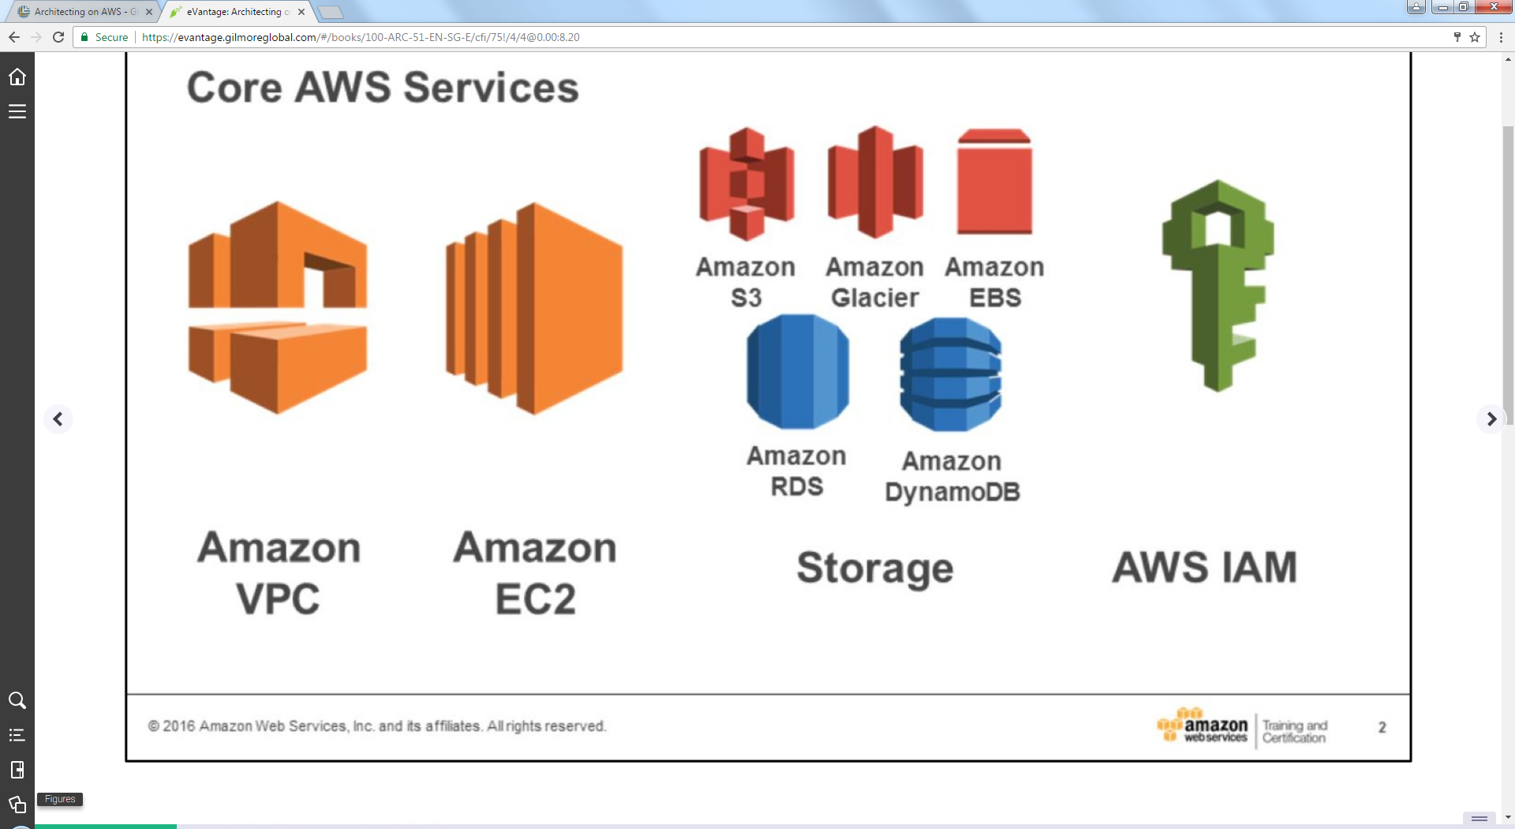

VPC: this is where u design and deploy your instances.

* 5 VPS /region
* VPC is empty machine room.
* Expands all VPC in a region
* 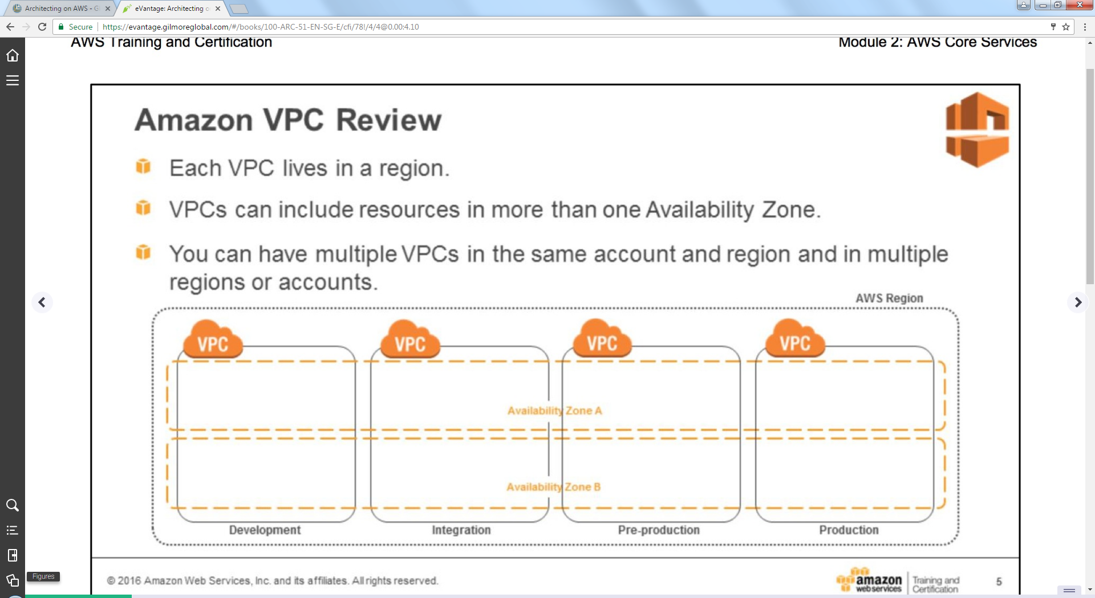

EC2: it is like your Linux or windows server on VM ware

EBS: Linux and windows file storage system

Block storage: one character in the file changed.

Object storage: entire files need to be changed (S3)

* ESB can be snapshotted
* Standard is SSD
* High throughput as they fetch 1MB of data every time

S3: object storage

* Bulk file storage
* WORM file system. (Write once read many).
* Once written it can only be read not updated.
* Sequential file system (good for big data).
* No storage issue, It scales forever.
* Top level folder or storage:- Bucket
* 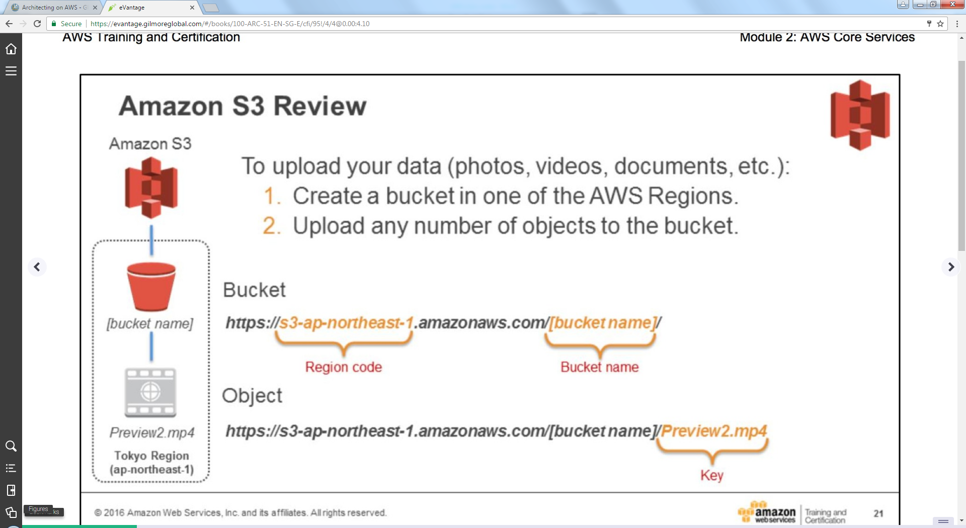

Glacier: for long term storage

* Cheaper
* Unlimited.
* Largest single file in glacier is 40 terabytes   
  (in S3 its 5 terabytes).
* Everything encrypted by default.
* Data retrieval slow (3-5 hrs. to begin).
* Not used typically in live applications.
* Only for long term backup.

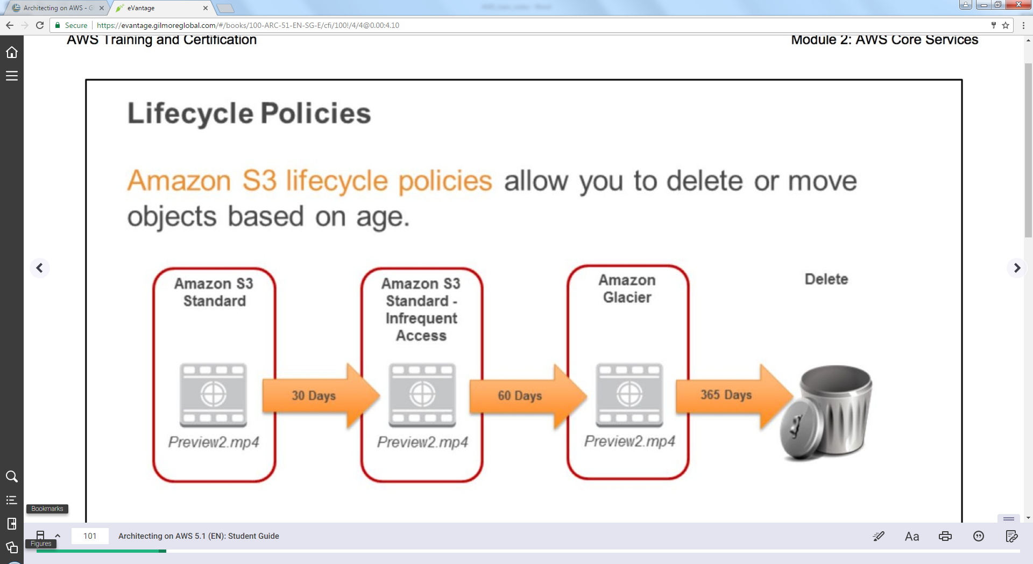

RDS Service:

* Only single active server can be launched.
* Cluster can’t be launched.
* Vertical scaling (make it bigger).

DynmoDB:

* No table size limits (DynmoDB), it’s very fast, it has key value storage and it is No sql db.

Eventual Consistency: happens when u have massively scaled services.

* S3, dynmodb services.
* When u upload files in S3 (file is bunch of blocks of data). -🡪 S3 takes each of its block and replicates (duplicating) across infrastructure.
* On deletion every block is deleted.

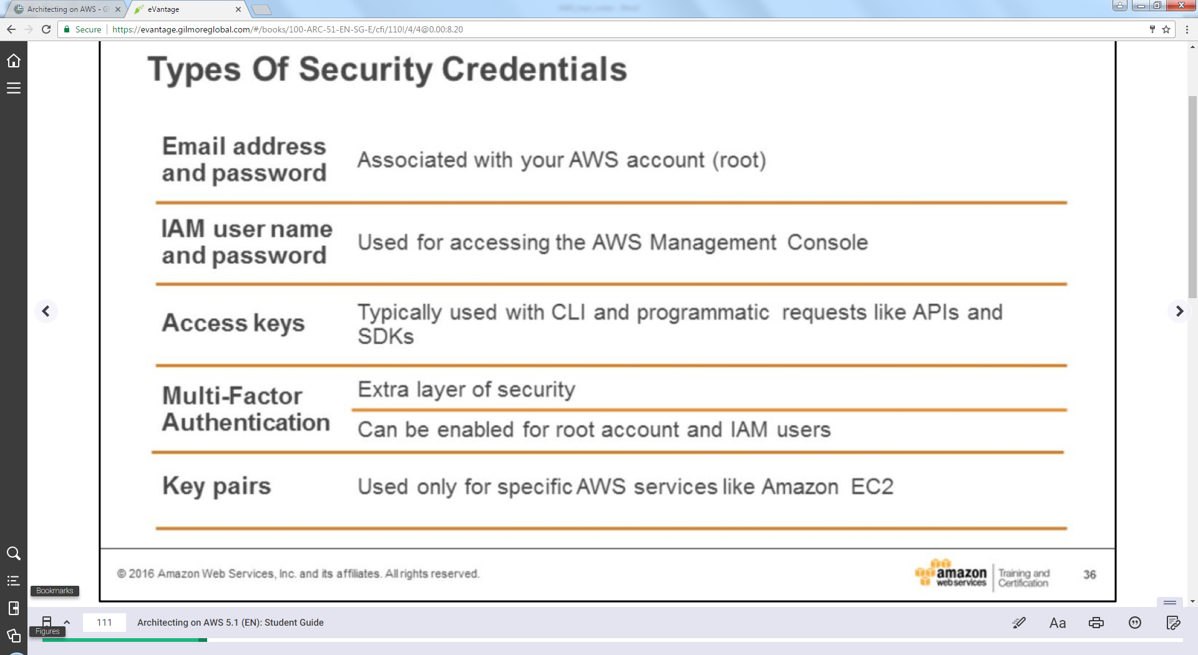

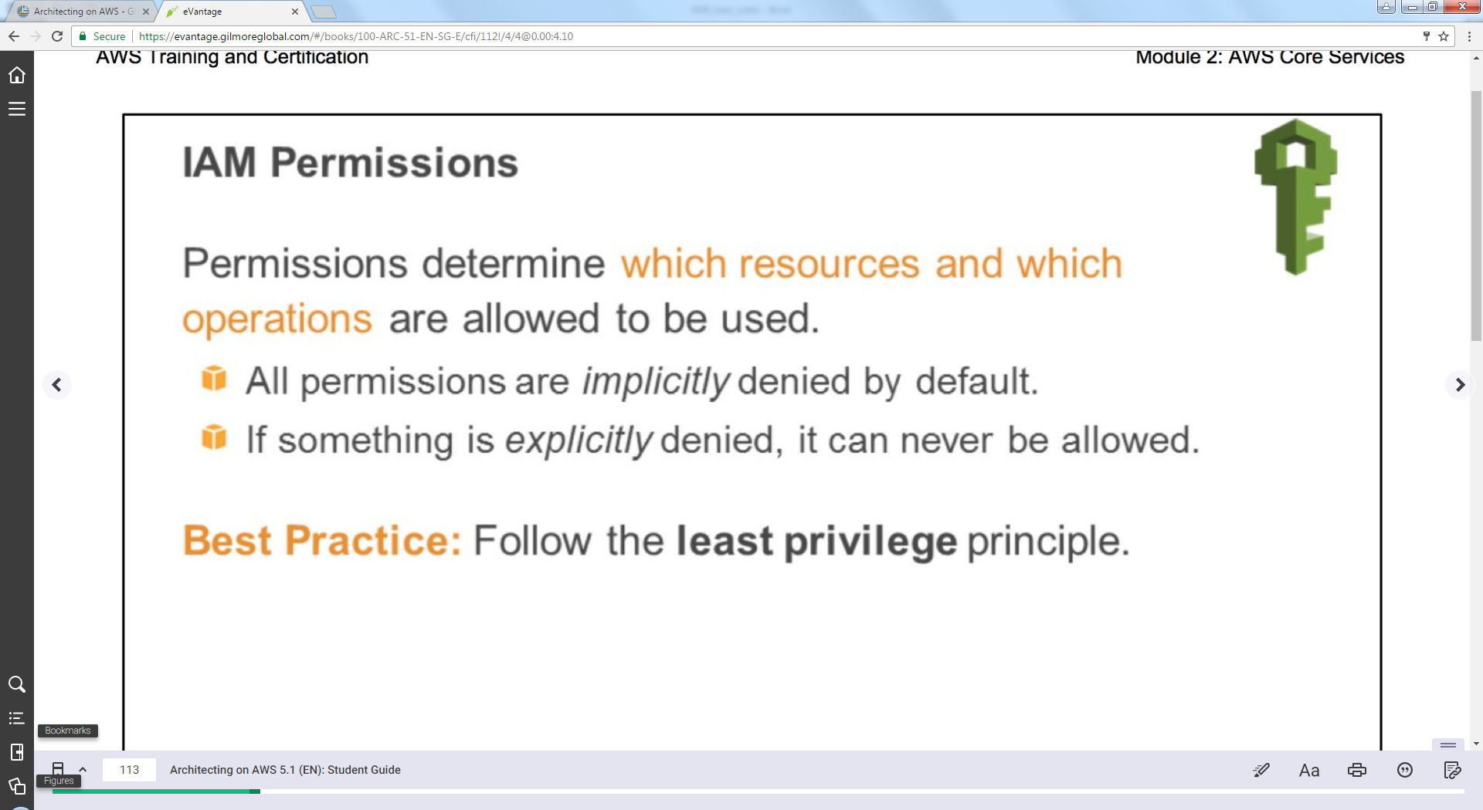

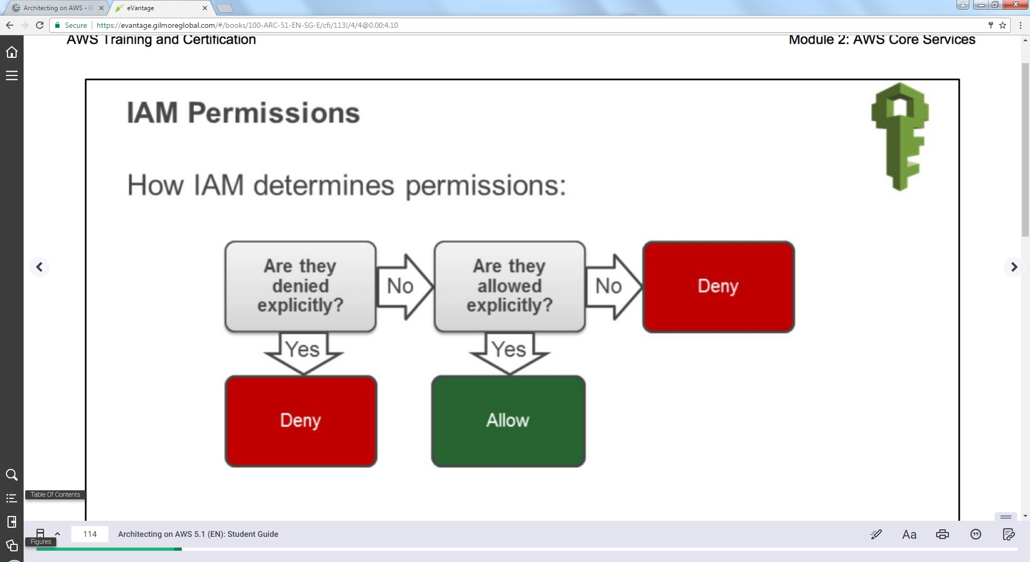

Security policies are JSON documents.

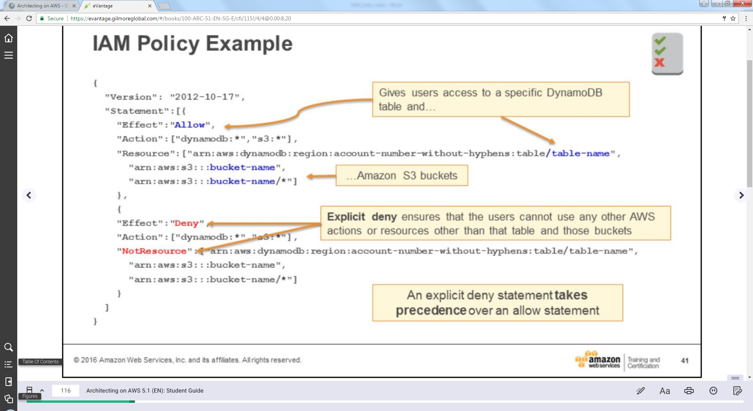

Arn: amazon resource name (we define resources with “arn”)

Note: <http://docs.aws.amazon.com/IAM/latest/UserGuide/reference_policies_elements.html>

Public subnet: route from subnet to internet

